WHA Injection Training
Table of Contents
8 rights of medication administration 1
Safe Injection Practices 2
Ventrogluteal Injection Technique 3
Deltoid Injection Technique 4
Injection Injuries 5
Vaccines offered by WHA 6
Commonly Administered Medications 7
Sign Off Sheet 10

8 rights of medication administration

All clinical employees have a responsibility for ensuring medications are administered correctly by following the 8 rights of medication administration:
- The right patient:
Verify the patient is the correct patient, check their name and birthdate
- The right drug
Verify the drug, medication or vaccine has been ordered by the clinician, and verify this with the patient
- The right dose
Verify the dose with the medical record
- The right route
Verify route given (mouth, intramuscular, subcutaneous, intradermal or IV)
- The right time
Verify the time is correct
- The right to know information about the medication given
Patients need to be informed and educated about medications given in WHA. Explain the medication that you are going to give, take a few minutes to review the vaccine information statement, patient education materials, or consent forms that are provided to the patient. Give the patient an opportunity to ask questions, and consult with the clinician if needed
- The right to refuse medication
If a patient decides to decline the medication, inform the clinician who ordered it and document
- The right documentation
Accurate, complete documentation in the correct patient electronic medical record. This documentation includes medication name, strength, dose, route, VIS date, consent forms, manufacturer, lot number, NDC and expiration date.

Safe Injection Practices

- Use aseptic technique to avoid contamination of sterile injection equipment

- Whenever possible, use single-dose vials for parenteral medications.

- Needles, cannula, and syringes are sterile, single-use items. They must never be reused for another patient, nor to access a medication or solution that might be used for a subsequent patient

- Enter medication vials with a new, sterile needle

- Do not administer medications from a syringe to multiple patients, even if the needle or cannula on the syringe is changed

- Use fluid infusion and administration sets (i.e., intravenous bags, tubing, and connectors) for one patient only and dispose appropriately after use. Once it has been used to enter or connect to a patient’s intravenous infusion bag or administration set, consider a syringe or needle/cannula contaminated.

- Medications that are pre-drawn are labeled with the time of draw, initials of the person drawing, medication name, strength, and expiration date or time. Pre-drawn medications expire at the end of the workday

- Each time the rubber septum on a multi-dose vial is accessed, it must be disinfected with alcohol and allowed to dry

- Multi-dose medications used for more than one patient are dated when they are first opened and are discarded within 28 days of opening or according to manufacturer’s recommendation, whichever comes first

- Draw up viscous (thick) medications with an 18-gauge needle and then administer it with proper size needle.

Maximum medication volume to be administered per site
  - IM Ventrogluteal: 3 mls
  - IM Deltoid: 1 ml
  - SQ various sites: 1 ml (adult) 0.5 ml (infant/child)

Ventrogluteal Injection Technique

When Do We Administer Medications in the Dorsogluteal Location?
WE DON’T!
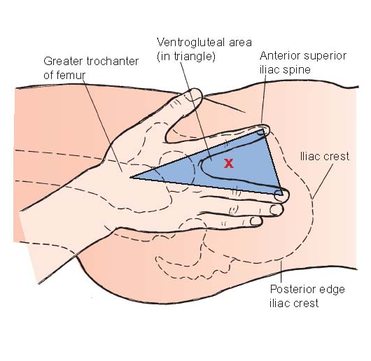
The dorsogluteal site should not be used for medication administration at WHA due to it being a higher risk location for hitting a major nerve & blood vessel.

Instead, we should be using the ventrogluteal location. It is ideal to have a patient lying on their side to make finding the anatomical landmarks easier.



However, if the patient has mobility issues or cannot lay on one side or the other, it is acceptable to identify these anatomical landmarks with the patient standing.

Deltoid Injection Technique


When finding the proper location for deltoid injection, have the patient put their hand on their hip. This allows you to feel the acromion process, avoiding the bursa in the shoulder. Ensure the patient’s arm is relaxed prior to administration.
When giving the injection – be sure to STRETCH the skin and not bunch it.

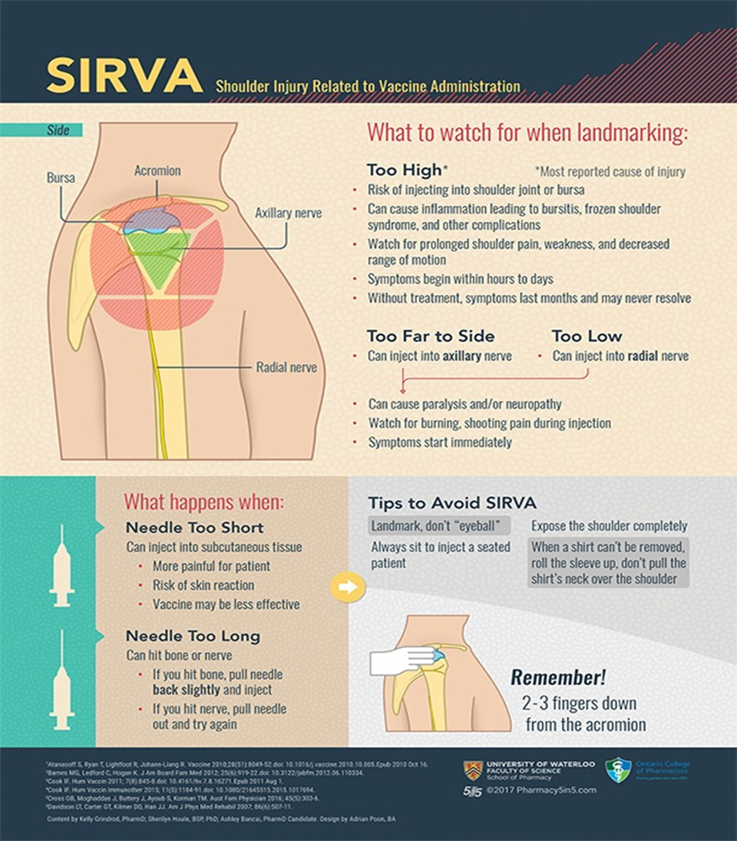
Injection Injuries

Vaccines offered by WHA
All immunizations given by WHA are given IM in the deltoid muscle. Be sure to choose the correct size needle to assure that you can insert the needle fully.
Quadrivalent Flu Vaccine (Fluzone) - Given yearly to protect against seasonal influenza. The seasonal flu vaccine protects against the influenza viruses that research indicates will be most common during the upcoming season. Our flu shots have no preservatives.
High Dose Flu Vaccine – Given to patients aged 65 and older, it contains four times the standard dose of the regular flu shot.
Tdap – Vaccine that protects against three different bacteria: tetanus, diphtheria, and pertussis (whooping cough). Boosters are needed every ten years. Also given to women in the third trimester of every pregnancy, usually at 28-week visit. It helps protect infants from pertussis through passive immunity. Infants will not get this vaccine until two months old.
Gardasil (HPV) - Gardasil is used to prevent genital warts, cancer of the cervix, anal cancer, and various cancers of the vulva or vagina. The administration of Gardasil has been associated with syncope (fainting), sometimes resulting in injury when falling. The syncope sometimes is associated with tonic-clonic movements and other seizure-like activity. Caution is recommended when administering the vaccine to individuals susceptible to syncope. Prior to vaccine administration, obtain a full set of vital signs (BP, P, O2, T and a POC Pregnancy Test (Unless patient declines). **Remember to document pregnancy test, even if patient declines. Assess for history of prior syncopal episodes, if present, administer in a lying down position. Observe patient for 15 minutes for adverse vaccine reactions, ex: anaphylaxis, before discharging from clinic. Given in three separate doses. The second dose is given 2 months after the first dose. Third dose given 6 months after the first dose.
Needle Guideline for Vaccines
Weight  Less than 130 lbs.  130 – 152 lbs.  153 – 200 lbs.  200+ lbs. | Gauge  22 -25 gauge  22 -25 gauge  22 -25 gauge  22 -25 gauge | Needle Length  5/8 – 1 inch  1 inch  1 – 1 ½ inch  1 ½ inch

Commonly Administered Medications

Depo Provera (Medroxyprogesterone Acetate) – Depo-Provera is a form of progesterone, a female hormone that prevents ovulation (the release of an egg from an ovary). It also causes changes in your cervical mucus and uterine lining, making it harder for sperm to reach the uterus and harder for a fertilized egg to attach to the uterus. Do not administer if patient is pregnant. Prior to medication administration, obtain a full set of vital signs (BP, P, RR, T). Observe patient for 15 minutes for adverse medication reactions, ex: anaphylaxis, before discharging from clinic. There is some flexibility with dosing. Can be given between weeks 11 – 15.
For patients who arrive for their Depo injection beyond the 15 week window, the .WHAHPIINJECTIONDOCUMENTATION smartphrase will provide guidance on how to handle the appointment. It is not required for the patient to be scheduled for an office visit with a provider to receive their Depo injection.
If the patient is agreeable, it is recommended to take a pregnancy test if they’ve been sexually active with male partners unprotected.
If the unprotected intercourse occurred more than 72 hours ago it is appropriate to administer the injection, then re-educate the patient on the importance of the timing of their injections.
If the unprotected intercourse occurred within the last 72 hours, the clinical support staff member should consult with a provider on whether it would be appropriate to offer emergency contraception such as Ella or Plan B.
Weight | Gauge | Length | Location
Up to 152 lbs. | 22 gauge | 1 Inch | Deltoid or Ventrogluteal
153-200 lbs. | 22 gauge | 1 – 1 ½ inch | Deltoid or Ventrogluteal
200+ lbs. | 22 gauge | 1 ½ inch | Deltoid or Ventrogluteal

Rhogam - used to prevent Rh immunization, a condition in which an individual with Rh-negative blood develops antibodies after exposure to Rh-positive blood. Given to RH negative women given at 28 weeks' gestation and when experiencing bleeding in pregnancy.
Weight | Gauge | Length | Location
Less than 130 lbs. | 22 gauge | 1 inch | Deltoid or Ventrogluteal
130 -152 lbs. | 22 gauge | 1 inch | Deltoid or Ventrogluteal
153 – 200 lbs. | 22 gauge | 1 – 1 ¼ inch | Deltoid or Ventrogluteal
200+ lbs. | 22 gauge | 1 – 1 ¼ inch | Ventrogluteal

Methotrexate- A medicine given for ectopic pregnancy. The medicine stops the fetus from growing. The mother's body then usually absorbs the fetal tissue. Because this medication is a chemotherapy drug, whoever draws up and administers this medication must wear full PPE, including double gloves. When charting this medication, it requires a dual sign off.
Hydroxy-progesterone (Makena) - Makena is a progestin indicated to reduce the risk of preterm birth in women with a singleton pregnancy who have a history of singleton spontaneous preterm birth. This medication is given weekly from 16-36 weeks' gestation.
Rocephin (Ceftriaxone) - Ceftriaxone injection is used to treat certain infections caused by bacteria such as gonorrhea or pelvic inflammatory disease. Rocephin must be reconstituted. Follow the instructions on the label; It can be diluted with 1:1 sterile water, 0.9% Sodium Chloride or 1% lidocaine (without Epinephrine) for IM administration only. Do not administer if patient has allergies to Rocephin or cephalosporins. Prior to medication administration, obtain a full set of vital signs (BP, P, RR, T). Observe patient for 15 minutes for adverse medication reactions, ex: anaphylaxis, before discharging from clinic.
Methotrexate  Makena  Rocephin | Gauge | Length | Location
Methotrexate  Makena  Rocephin | 21 gauge | 1 ½ inch | Ventrogluteal

Ketorolac (Toradol)- Toradol (ketorolac) is a nonsteroidal anti-inflammatory drug (NSAID). Ketorolac works by reducing hormones that cause inflammation and pain in the body.
Gauge | Length | Location
22 gauge | 1 – 1 ½ inch | Ventrogluteal

Estradiol Valerate (Delestrogen) is a form of estrogen used to treat symptoms of menopause such as hot flashes, vaginal dryness, burning and irritation. Very thick.
Estradiol Valerate  Testosterone cypionate | Gauge | Length | Location
Estradiol Valerate  Testosterone cypionate | 20 gauge | 1 ½ inch | Ventrogluteal
Testosterone cypionate (Depo-Testosterone) is a form of testosterone used for hormone replacement therapy. Very thick.

Lupron - Lupron is a synthetic gonadotropin-releasing hormone used to treat symptoms of endometriosis and/or uterine fibroids. Do not administer if patient is pregnant or has allergies to leuprolide or similar medicines such as buserelin, goserelin, histrelin, or nafarelin. Prior to medication administration, obtain a full set of vital signs (Blood Pressure, Pulse, Respiratory Reading, Temperature). Observe patient for 15 minutes for adverse medication reactions, ex: anaphylaxis, before discharging from clinic
Needle Supplied with Medication | Ventrogluteal

Sign Off Sheet
VG injection only needs 1 observed and 1 given to be signed off by supervisor | Deltoid  Preceptor Initials and Date | Ventrogulteal  Preceptor Initials and Date
Observation #1
Observation #2 |  | X
Observation #3 |  | X
Observation #4 |  | X
Observation #5 |  | X
Given #1
Given #2 |  | X
Given #3 |  | X
Given #4 |  | X
Given #5 – Supervisor MUST observe |  | X

Final Supervisor Sign Off
Deltoid | Ventrogluteal

